CHURCH WIDE EDUCATION
(11:30-12:30 in Litten Hall downstairs or in the children’s education room)
(Childcare is available through this time)
(*Growing in God’s Love: A Story Bible)
JANUARY 7
Time to Help Undecorate
Join the team effort to put away the Christmas decorations.
(No Adult Forum and No Children's Education today)

JANUARY 14
ADULT FORUM
Slavery to Freedom Art Installation 2024
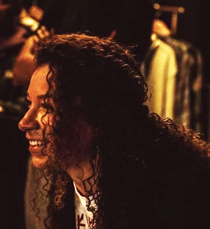
Presenter- Visual Artist Mila Lynn
This year’s installation is meant to celebrate MSU’s Osteopathic College of Medicine’s 24 years of education, celebration, and healing by way of the Slavery to Freedom Speaker Series. The artwork will consist of 24 different pieces all telling their own story of Black culture, and collectively coming together to showcase how dynamic we are. Pieces will be done on several types of “canvas,” including vinyl records, music sheets, and cassette tapes as a way to highlight how much of our history has been told via word of mouth and through music.

CHILDREN’S FAITH FORMATION
Jesus is Baptized, “An Awesome Day”
Children will learn more about the meaning of Baptism and how being “marked in Christ” can effect their daily lives. (p. 202 “An Awesome Day” *)

JANUARY 21
ADULT FORUM
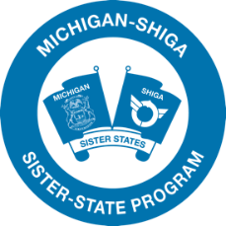
Led by Prince Solace
Have you heard of Otsu, Shiga Japan? Michigan and Shiga became sister states in 1968 and have deepened our mutual understanding, learned from each other, and grown our friendship. In October 2023, 37 Goodwill Mission delegates from Michigan visited Shiga and had a wonderful time through homestay and other programs. We would like to share this wonderful friendship and exchange with you. Please join!

CHILDREN’S FAITH FORMATION
Fish for People! “Follow Me!”
Children will learn more becoming a disciple for Christ. (p. 206“Follow Me” *)

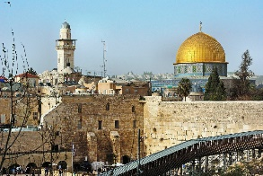
JANUARY 28
ADULT FORUM
Recent Events in the Middle East
Led by Rev. Stan Jenkins

CHILDREN’S FAITH FORMATION
LOVE “The Most Important Thing to Remember!”
Children will learn more about how to show care and concern for the people around them. (p. 168)

